# How to use CrossoverAddon

The CrossOverAddon provides a toolbar within Excel with functions to help in robustly discriminating between management alternatives. The functions identify crossover point scenarios that describe circumstances where the preferred management alternative crosses over.

Note: This Excel add-in is a research product and is provided as-is without any warranty. Excel does not allow actions by add-ins to be undone. Make sure to save as you go, and if necessary close the file if you want to undo changes.

## Install and activate the add-on

<https://support.office.com/en-ca/article/Add-or-remove-add-ins-0af570c4-5cf3-4fa9-9b88-403625a0b460#bmexceladdin>

1. Open the Add-ins dialog
   1. Click File – Options – Add-Ins
   2. In the Manage box, select “Excel Add-ins” and click Go
2. Install CrossoverAddon by clicking browse and selecting the downloaded file “CrossoverAddon.xlam”
3. Ensure the add-in is activated – the checkbox next to it should be ticked
4. Activate the built-in “Solver” add-in – the checkbox next to it should be ticked
5. Click OK to close the Add-ins dialog.
6. The toolbar for crossover point analysis will appear in the DATA tab

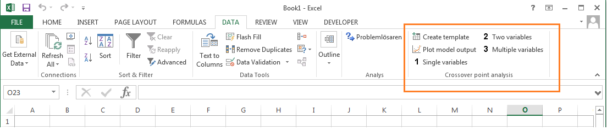

## Create template

This button inserts a template for the table of variables that will be manipulated by the crossover analysis.

1. Select a cell which will be the top-left corner of the table
2. Click on the ‘Create template’ button.
3. A dialog box will appear to confirm that you want to continue. Click Yes.
4. A table is inserted with example data and comments (marked by red triangles) describing key columns/cells

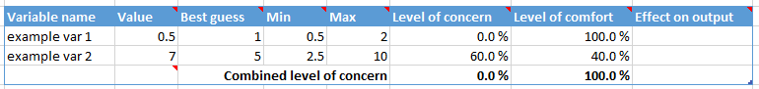

The table lists one variable per row, including its current value in the analysis, best guess value, minimum and maximum values of concern, as well as calculated values for level of concern, level of comfort and effect on output. Definitions of each of these are given below.

|  |  |
| --- | --- |
| Value | Values in this column will be manipulated by the crossover methods. Please modify your analysis to depend on these cells. |
| Best guess | This column should list the value of the variable that you use within your original analysis, i.e. the best guess estimate based on best available information |
| Min | This column should list the minimum value of the variable, below which a crossover point would not be of concern. By default it is set to half the best guess value. It is expected that this value would be updated during the analysis in response to cross-over points identified |
| Max | This column should list the maximum value of the variable, above which a crossover point would not be of concern. By default it is set to half the best guess value. It is expected that this value would be updated during the analysis in response to cross-over points identified |
| Level of concern | This column lists the level of concern (LOC) of the variable,  i.e. how close it is to the best guess relative to the minimum and maximum limits  The combined LOC of multiple variables is the LOC of the variable of least concern, i.e. the minimum |
| Level of comfort | This column lists the level of comfort of the variable, i.e. how far it is from the best guess relative to the minimum and maximum limits It is the complement of level of concern, i.e. level of concern + level of comfort = 100% |
| Effect on output | This column lists whether increasing this variable makes the value of alternatives either 'closer' or 'further' apart. It is automatically calculated and used by the 'Line search' algorithm in the 'Multiple variables' method |

The bottom row of the table is a footer summary line.

Together, the values of the variables define a scenario corresponding to a specific set of assumptions about the assessment of the management alternatives. The combined level of concern of this scenario is given by the variable of least concern. A scenario is only as concerning as it least concerning variable. The combined level of concern/comfort is shown in the footer cells in the columns “Level of concern” and “Level of comfort”.

In the column “Value”, the cell is reserved for the 'Line search' algorithm in the 'Multiple variables' method. Within this method, values are calculated as a function of level of concern, which is stored here.

## Adapting the template to fit your existing analysis

To begin with, the template should be modified to list the variables in your analysis and their best guess values.

As an example, we use an analysis that compares the water footprints of different diets. The necessary information is provided in “Supplementary data. Diet inputs” and “Supplementary data. Worksheets”.

Jalava, M, M Kummu, M Porkka, S Siebert, and O Varis. 2014. “Diet Change—a Solution to Reduce Water Use?” Environmental Research Letters 9 (7). IOP Publishing: 074016. <http://dx.doi.org/10.1088/1748-9326/9/7/074016>

A simplified version is provided in the file “change in diet footprint crossover example.xlsx”

The simplified file includes three alternatives (one per sheet):

* Original diet (OD) corresponds to an existing average diet in a country according to FAO consumption data
* Scenario 1 (RD) corresponds to a diet that has been modified to meet recommended dietary requirements
* Scenario 5 (A0) corresponds to a diet that has been modified to meet recommended dietary requirements without consuming animal products

In each sheet, the analysis calculates footprints (in litres/person/day) by multiplying consumption in different food groups (in grams/person/day) with blue and green water footprint per gram of foodstuff consumed after food waste (in litres/gram).

For the purposes of this example, we are interested in identifying crossover point scenarios involving changes in food group footprints in Finland.

1. We modify the crossover template to list the food group footprints (“Variable name”) and their values (“Value” and “Best guess”). Minimum and maximum values are automatically set as half and twice of the best guess value as default values.

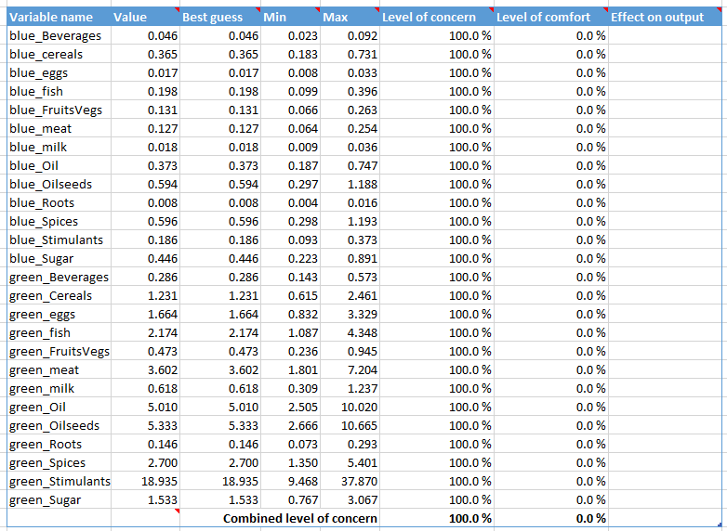

1. We modify the original analysis to refer to these cells, i.e. the values for Finland in wfp_per_gram_eaten are replaced by formulas in the sheet “wfp_per_gram_eaten”



1. For convenience, we also report the results of the analysis (i.e. the total footprints) in the sheet “Crossover analysis”

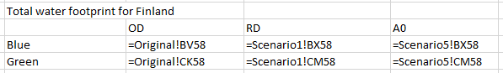

1. Suppose we are interesting in comparing the total footprint of the recommended diet (RD) and no-meat diet (A0). The reduction in footprint by eliminating meat consumption is given by RD-A0, which we calculate on the sheet “Crossover analysis” for convenience

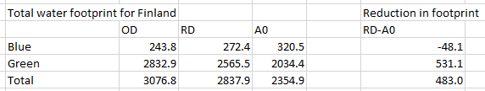

The table is now ready for further analyses. The sheet “Crossover analysis” provides an easy means of changing assumptions (here, about food group footprints for Finland) and seeing the effect on outputs (here, total footprints for different diets).

## Plot model output

This button adds a new sheet with a plot of model outputs as a function of a single variable. This helps to visualise a single variable crossover point.

A dialog is shown. Here we vary the “green_cereals” footprint for 100 values between 0 and 10, and plot the total footprint for RD and A0.

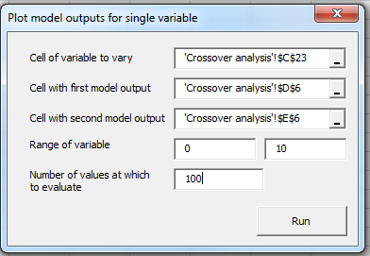

The new sheet shows the value of the variable, the two model outputs and the corresponding level of concern, i.e. how close the value of the variable is to current best guess relative to the bounds. All other variables are kept at their initial values (in the column “Value”)

The crossover point is seen as the point at which the two model outputs cross, i.e. around a value of 4.6 L/g for the green footprint of cereals.

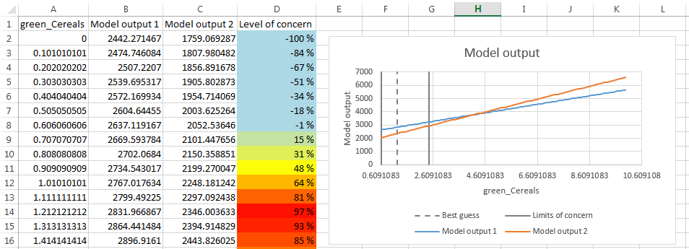

## Single variables

This button produces a table in a new sheet showing single variable crossover points, i.e. values at which two management alternatives are of equal value when varying one variable at a time.

Here we’re interested in crossover points where the total footprint of RD is equal to the total footprint of A0 (i.e. RD - A0=0). We want to identify single variable crossover points for all the variables.

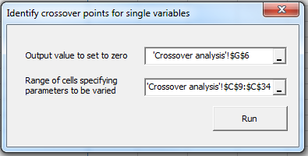

Each row shows a separate crossover point scenario, with the level of concern updated dynamically based on the values of the best guess and minimum and maximum bounds.

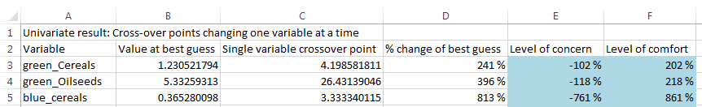

Note that crossover points may be identified outside of the bounds of concern. Excel’s goal seek function does not allow bounds to be specified.

## Two variables

This button adds a new sheet with a plot showing two variable crossover points, i.e. the values of a pair of variable at which two management alternatives are of equal value.

Here, we look at the effect of changing the green water footprint of meat and cereals, calculating the cross-over points at 100 values of green_meat between 0 and 8.

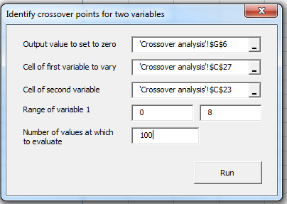

Each row shows a cross-over point scenario, consisting of values for both green_meat and green_cereals. These points are shown on the plot, coloured according to their level of concern. Some cross-over points do fall within the bounds of concern.

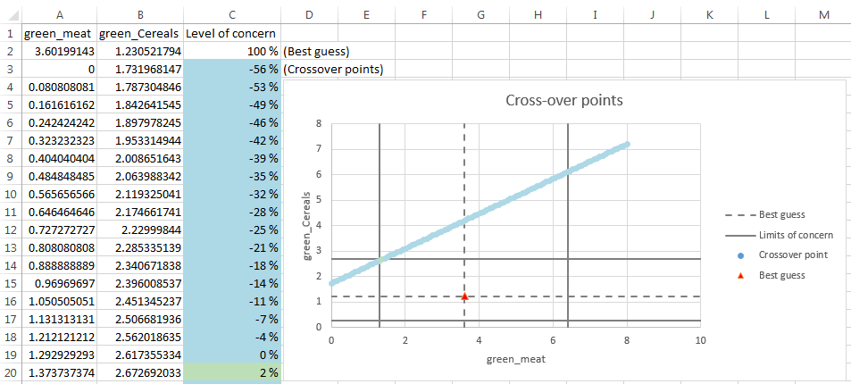

## Multiple variables

This button modifies the values of variables to identify a multivariate crossover point of greatest concern, i.e. a scenario where management alternatives are of equal value and that is close to the best guess relative to the given limits of concern

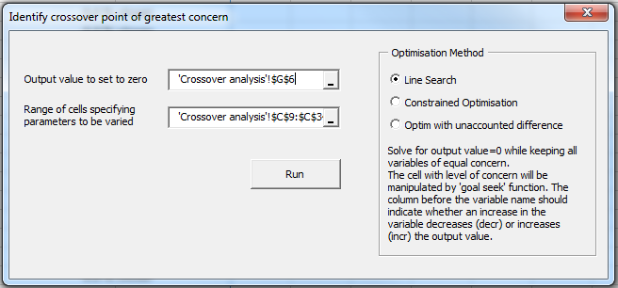

This generates a single crossover point scenario consisting of values for each of the selected variables.

